Anil Maharjan, Siddhant Pageni, Eria O. Pinyi

  Supevisor: Siamak Tavakoli

Technical document

Overview: WebStore is a project which is the part of course requirement. In this project we are simulating the online shopping by creating services for Product, customer, cart and order.

# Steps for execution

Zipkin Server: Run the zipkin server from command as:

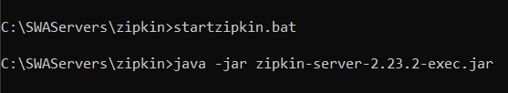

Navigate to url: localhost:9411

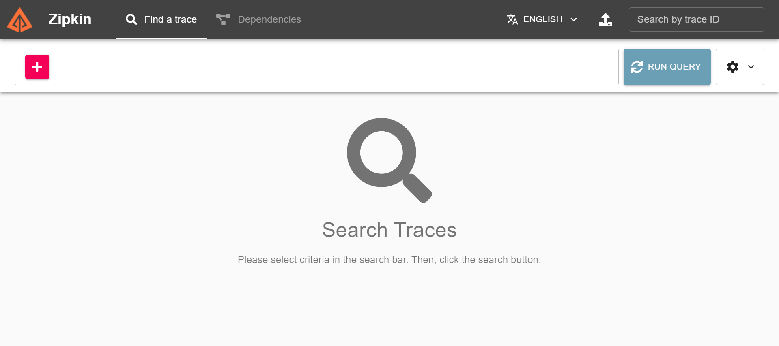

Kafka: Configure the log path for Kafka in files named:

**config\server.properties and config\zookeeper.properties**





### Start the Zookeeper:



### Start the Kafka:



### Start the Kafka Magic:



Navigate to url: localhost:5000

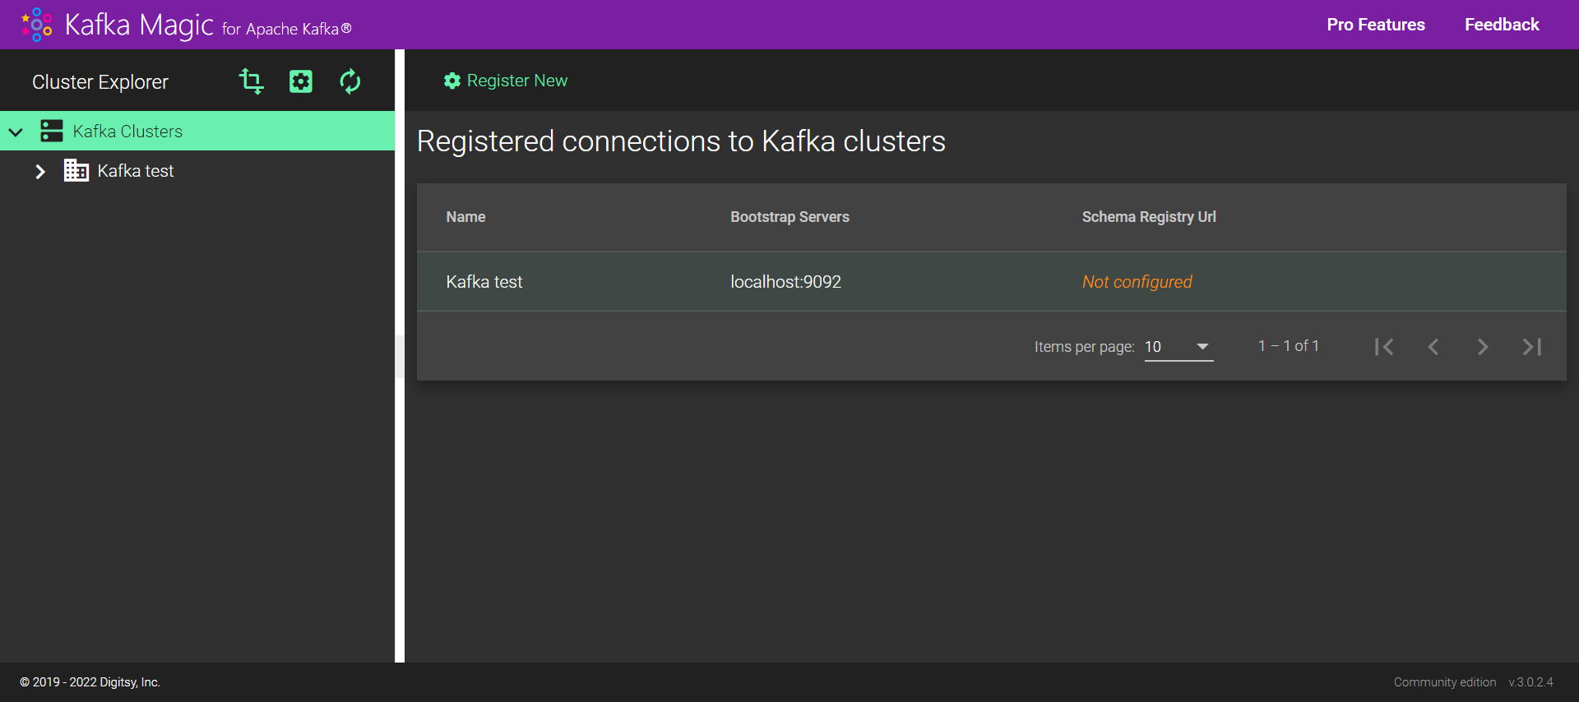

Config Service: Config service is an external configuration service that maintain the configuration of the services of the application



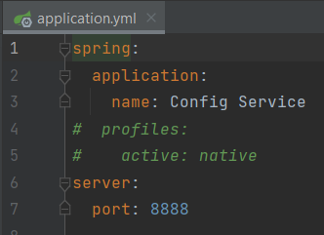

Eureka Registry Service: This service is like a phone directory. It holds the information about the client-service application. Client can register themselves with this service and lookup whenever it is required. For fallback we have created Fallback Eureka Registry Service. Start the fallback Eureka Registry Service too for ensuring the high availability of the service.

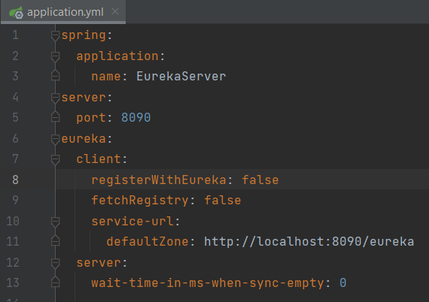

API Gateway: This is the entry point for the end user. All the requests are passed via API gateway. We have used the resilience (circuit-breaker) with graceful fallback mechanism

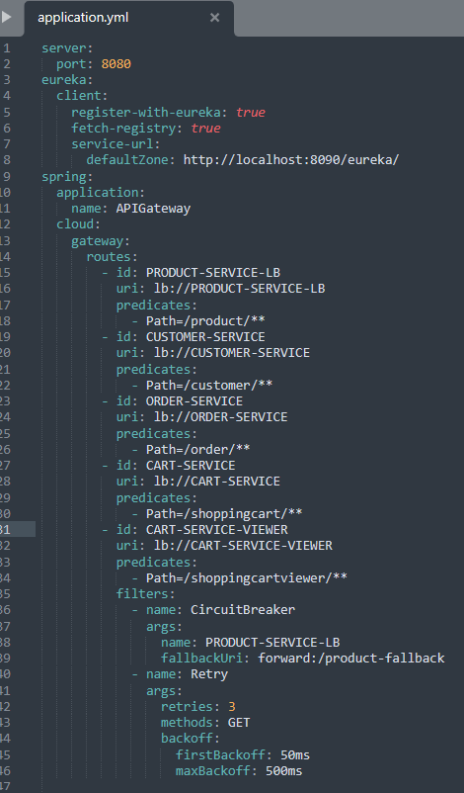

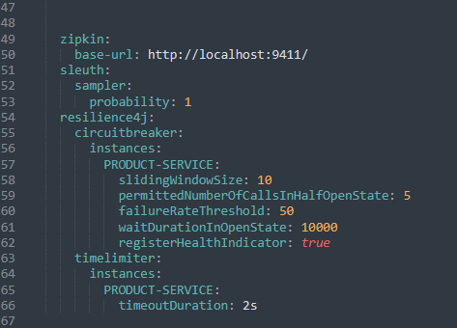

Run Load Balancing Server: We are creating multiple instances of the product service thus ensuring it divides the request among client in round robin pattern

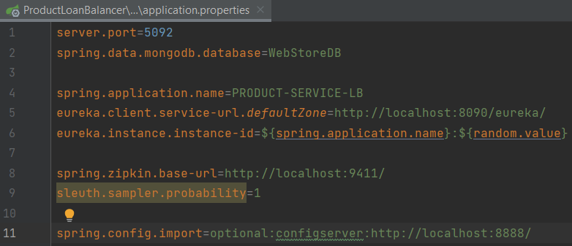

Start the Product Service Instances: This service carries out the action related to products like add, remove, list and view.

Since, we need to create the multiple instances of this service, we need to assure that **server.port is set to 0**

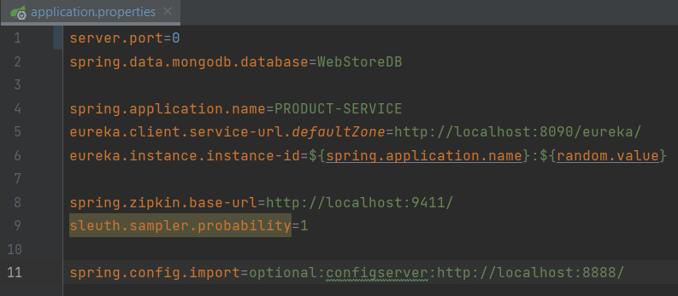

You can create multiple instances of the service as below

### Go to edit configuration:

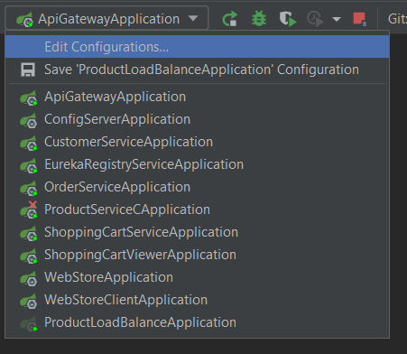

Click plus icon to add new configuration:

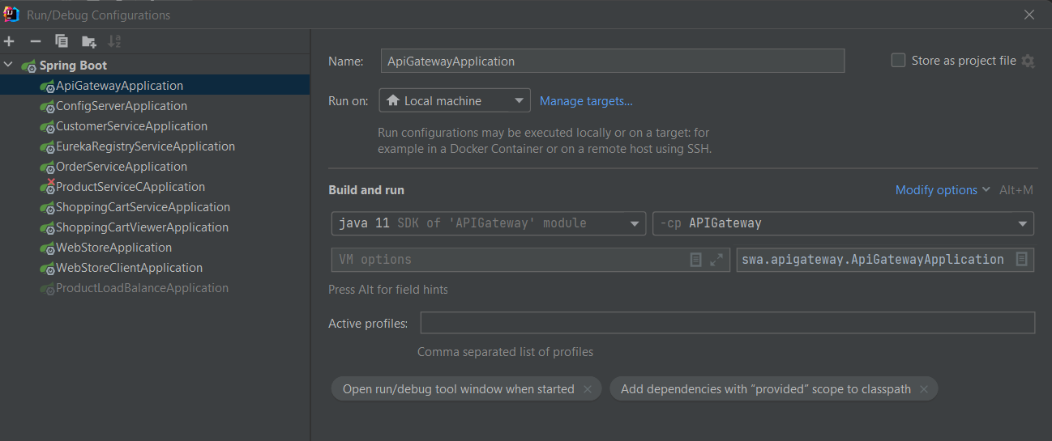

Change the name

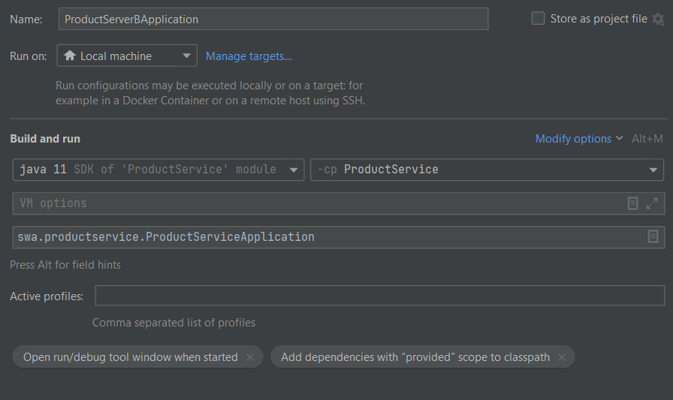

Start the Customer Service: This service provides the functionality related to customers like add, remove, list and view

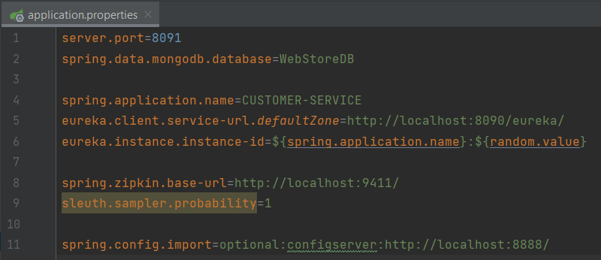

Start the Shopping cart service: This service provides the functionality related to creating new cart, add product in cart, remove product from cart and change the quantity on the product.

This service acts as message initiator for Kafka. The message is initiated as and whenever the action is carried out this service. For messaging we have converted the object to string and string message had been passed.

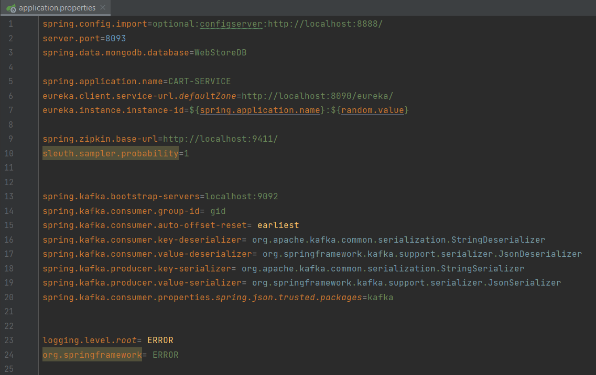

Start the Shopping Cart Viewer: This service as act a Kafka message consumer. It consumes the message published by the producer and take necessary action accordingly

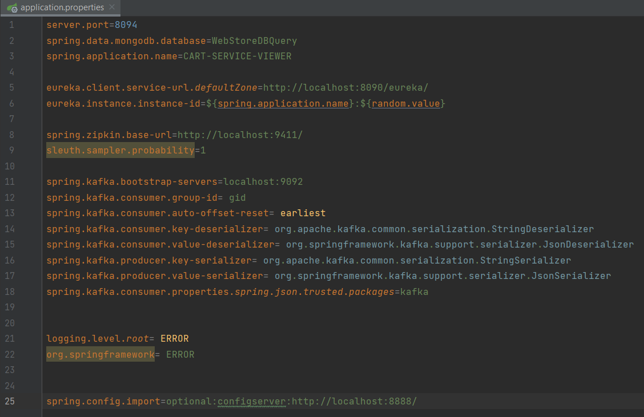

Start the Order Service: This service gets called when the cart is checked out. New order is created in the database once the check is called. We can even view the list of orders

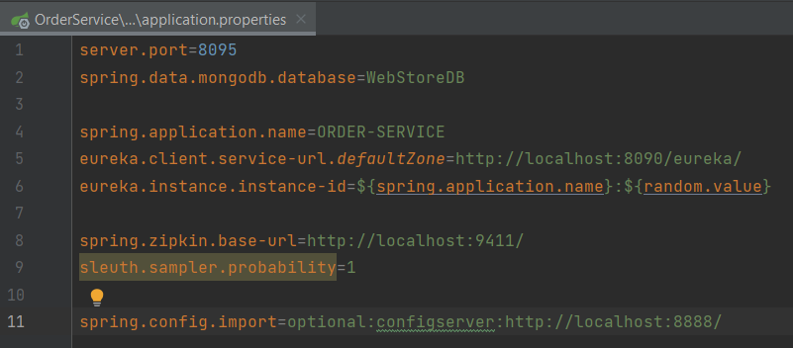

RestTemplate: This application is used for consuming the services that have created.